**Assignmnet 1**

1. What is the output of this program?

class variable_scope {

public static void main(String args[])

{

int x;

x = 5;

{

int y = 6;

System.out.print(x + " " + y);

}

System.out.println(x + " " + y);

}

}

a) 5 6 5 6  
b) 5 6 5  
c) Runtime error  
d) Compilation error

1. What is the output of this program?

class dynamic_initialization {

public static void main(String args[])

{

double a, b;

a = 3.0;

b = 4.0;

double c = Math.sqrt(a * a + b * b);

System.out.println(c);

}

}

a) 5.0  
b) 25.0  
c) 7.0  
d) Compilation Error

1. What is the output of this program?

class selection_statements {

public static void main(String args[])

{

int var1 = 5;

int var2 = 6;

if ((var2 = 1) == var1)

System.out.print(var2);

else

System.out.print(++var2);

}

}

a) 1  
b) 2  
c) 3  
d) 4

1. Which of the following statements is correct?  
   a) Public method is accessible to all other classes in the hierarchy  
   b) Public method is accessible only to subclasses of its parent class  
   c) Public method can only be called by object of its class.  
   d) Public method can be accessed by calling object of the public class.
2. What is the output of this program?

class box {

int width;

int height;

int length;

}

class mainclass {

public static void main(String args[])

{

box obj = new box();

obj.width = 10;

obj.height = 2;

obj.length = 10;

int y = obj.width * obj.height * obj.length;

System.out.print(y);

}

}

a) 12  
b) 200  
c) 400  
d) 100

1. What is the output of this program?

class string_demo {

public static void main(String args[])

{

String obj = "I" + "like" + "Java";

System.out.println(obj);

}

}

a) I  
b) like  
c) Java  
d) IlikeJava

1. A. Write an application containing an array of 15 double values. Include a method to sort and display the values in ascending order. Compile, run, and check the results. Save the file as SortDoubles.java.

b. Modify the SortDoubles application to prompt the user whether to view the list in ascending or descending order. Save the file as SortDoublesWithOption.java.

1. Table shows the various services offered by a hair salon, including its prices and times required:

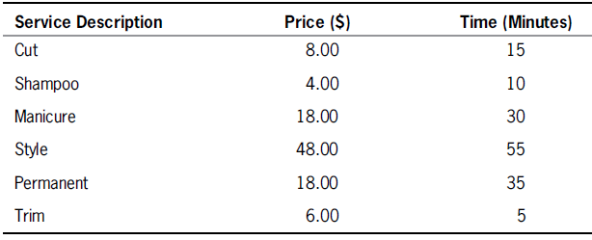

Create a class that holds the service description, price, and the number of minutes it takes to perform the service. Include a constructor that requires arguments for all three data fields and three get methods that each return one of the data field’s values. Save the class as Service.java.

b. Write an application named SalonReport that contains an array to hold six Service objects, and fill it with the data from Table Include methods to sort the array in ascending order and descending order by each of the data fields. Prompt the user for the preferred sort order, and display the list of services in the requested order. Save the program as SalonReport.java.